PXE Network OS Deployment Documentation
📌 Overview
This document explains how to install Windows Operating System over a network using PXE (Preboot Execution Environment) with Serva.

🎯 Objective
To deploy Windows OS on client systems through LAN without using a bootable USB device.

🖥️ Requirements
Hardware:
- Server System (PXE Server)
- Client System (Target PC/Laptop)
- LAN Network (Same Network)
Software:
- Serva (PXE Server Tool)
- Windows ISO File

⚙️ Step 1: Download and Setup Serva
- Download Serva from official website: https://www.vercot.com/~serva/
- Extract the Serva ZIP file
- Create a folder:
C:\SERVA_ROOT
- Run Serva as Administrator

⚙️ Step 2: Configure Serva
- Open Serva → Settings
- Enable:
  - TFTP Server
  - DHCP Server

- Set TFTP Root Directory:
C:\SERVA_ROOT
- Save settings and restart Serva

📁 Step 3: Add Windows Installation Files
- Inside SERVA_ROOT, create folder structure:
- WIA_WDS
- └── Windows_10
- Mount Windows ISO
- Copy all files into the above folder

💻 Step 4: Configure Client System
- Connect client to same LAN
- Restart system
- Enter BIOS/UEFI
- Enable:
  - Network Boot / PXE Boot
- Set Boot Priority to Network

🌐 Step 5: Boot from Network
- Restart client system
- Press Boot Menu Key:
  - Dell → F12
  - HP → Esc / F9
  - Lenovo → F12
- Select Network Boot

🪟 Step 6: Install Windows
- PXE boot menu appears
- Select Windows installer
- Follow installation steps
- OS installation completes

⚠️ Issues Faced & Solutions
1. WIA_WDS_SHARE Error
- Cause: Incorrect folder structure
- Solution: Verify correct folder naming

2. Missing pxeboot.n12
- Cause: Missing boot files
- Solution: Copy correct boot files from ISO

3. PXE Boot Not Working
- Check network connection
- Verify DHCP settings
- Ensure same LAN

4. UEFI / BIOS Issues
- Disable Secure Boot
- Enable Legacy/UEFI accordingly

🛠️ Tools Used
- Serva
- Windows ISO
- LAN Network

📸 Screenshots

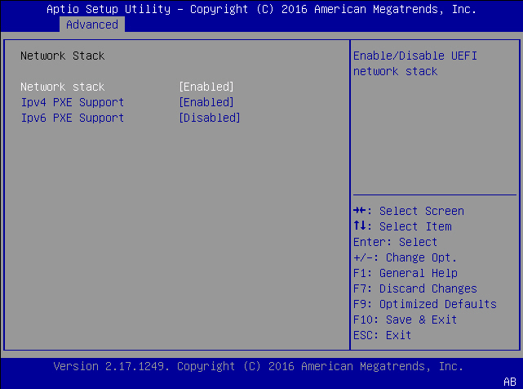

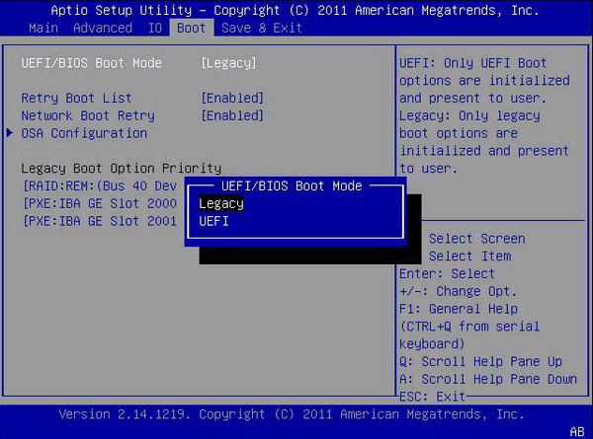
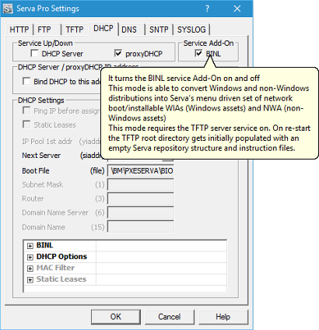

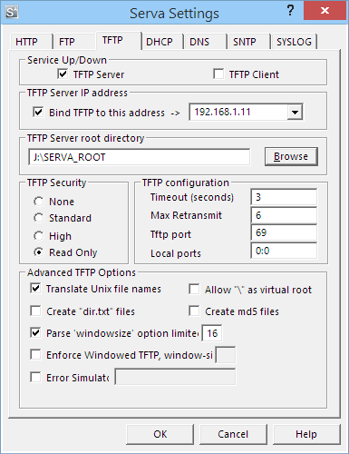

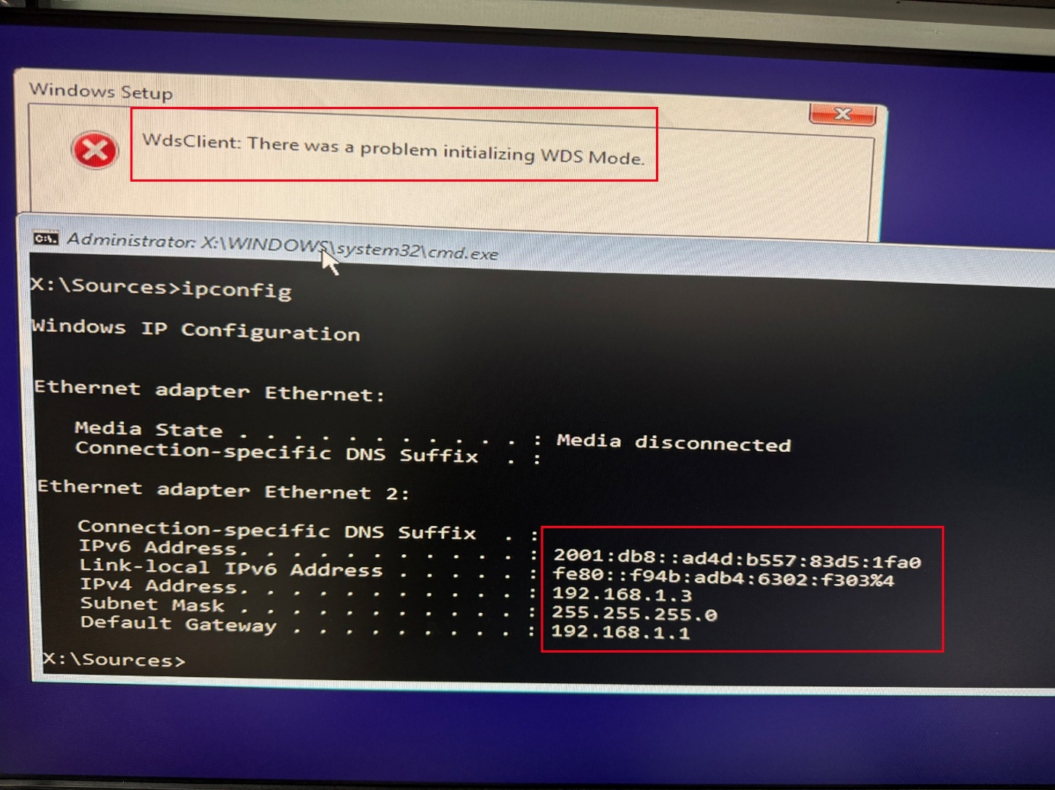

✅ Conclusion
PXE deployment simplifies OS installation over network and eliminates the need for physical boot media. It is efficient for managing multiple systems in an organization.

